Algebra 1: Unit 8, Lesson 5

- Three examples of equivalent quadratic equations, where $a=1$, are shown.
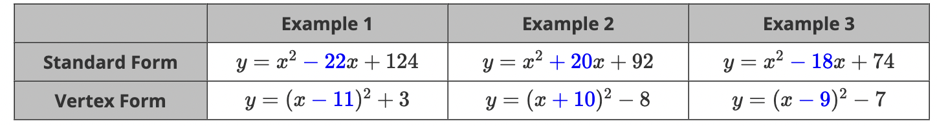
What is the relationship between the blue number in standard form $(b)$ and the blue number in vertex form $(h)$?
$b$ divided by $2$ equals $h$

- The algebra tiles shown on the product mat represent the expression $x^{2}+10x-9$.
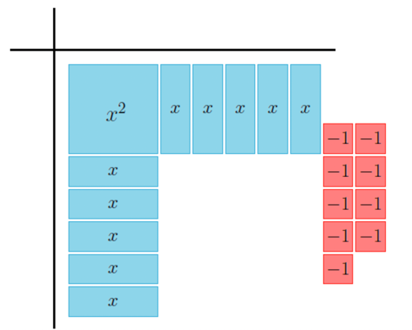

What algebra tiles are needed to complete the square?
$9$ negative tiles

- The algebra tiles shown on the product mat represent the trinomial $x^{2}-6x+14$.
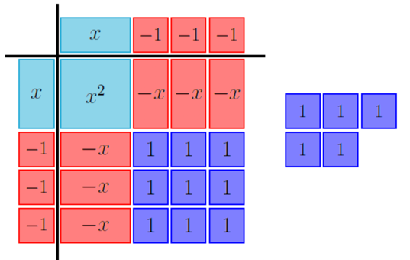
Determine if ${(x+3)}^{2}+5$ is equivalent to $x^{2}-6x+14$.
It is not equivalent.

